ICT 1
Website #1
http://fergusonfoundation.org/btw-students/fish-identification/

Complete the table below
The first table is a guide to how to navigate the website

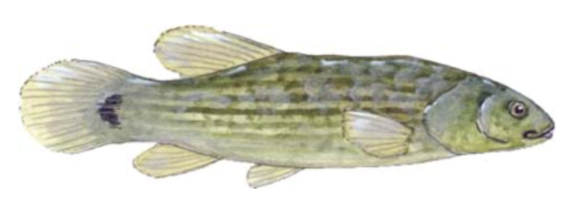

Click Fish #1 and keep your fish hovered over the fish

Question 1. Does this fish have barbels on its chin? 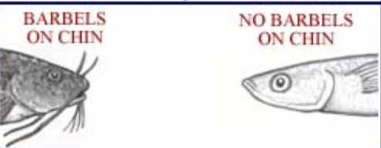 | No, this fish doesn’t. Click the box “no barbels on chin”  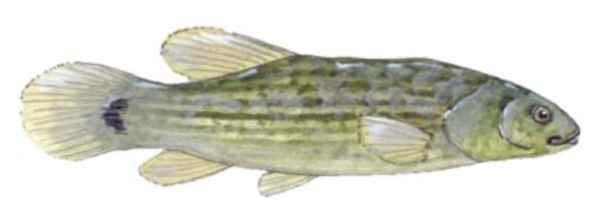
Question 2: Does this fish have a forked tail fin?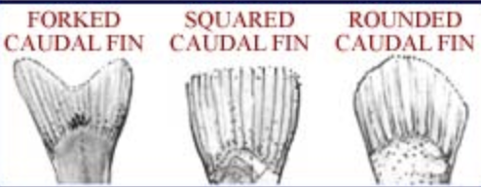 | No, this fish doesn’t. Click the box “caudal fin not forked”  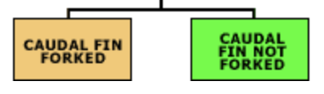
Question 3: Does the fin have a black bar? | Yes, this fish does. Click the box “Black bar at base of caudal fin”  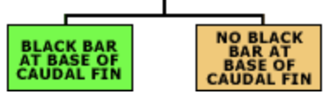
Identification? | Eastern mudminnow!

Fish | Name | Fact about this fish
2
3
4
5

6

7

8

9

10

